Name: M.Sai Chaitanya Roll No:2520090023
Practical week-1
Query 1: Create the database
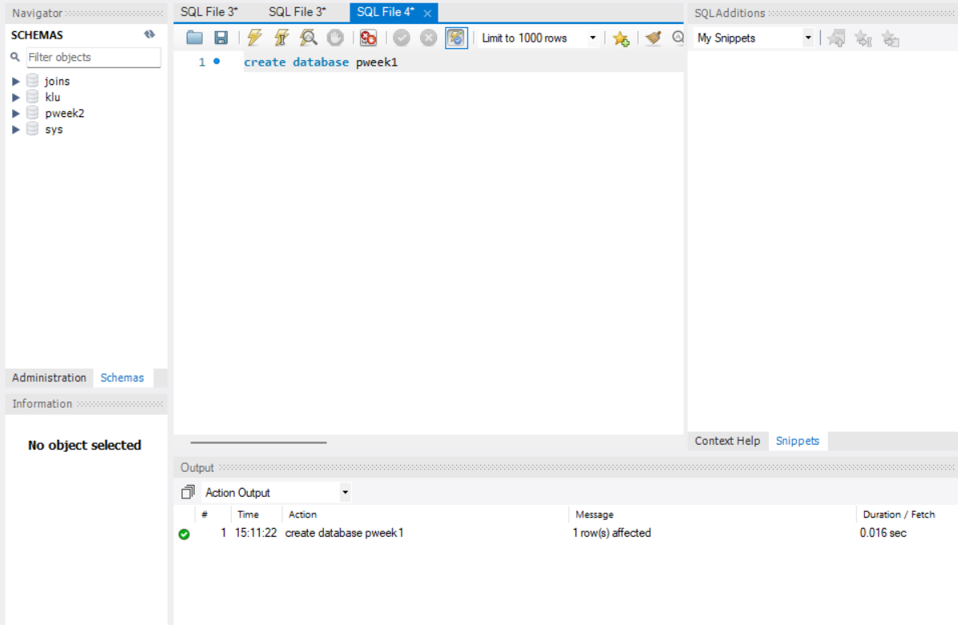

Query 2: Select the database
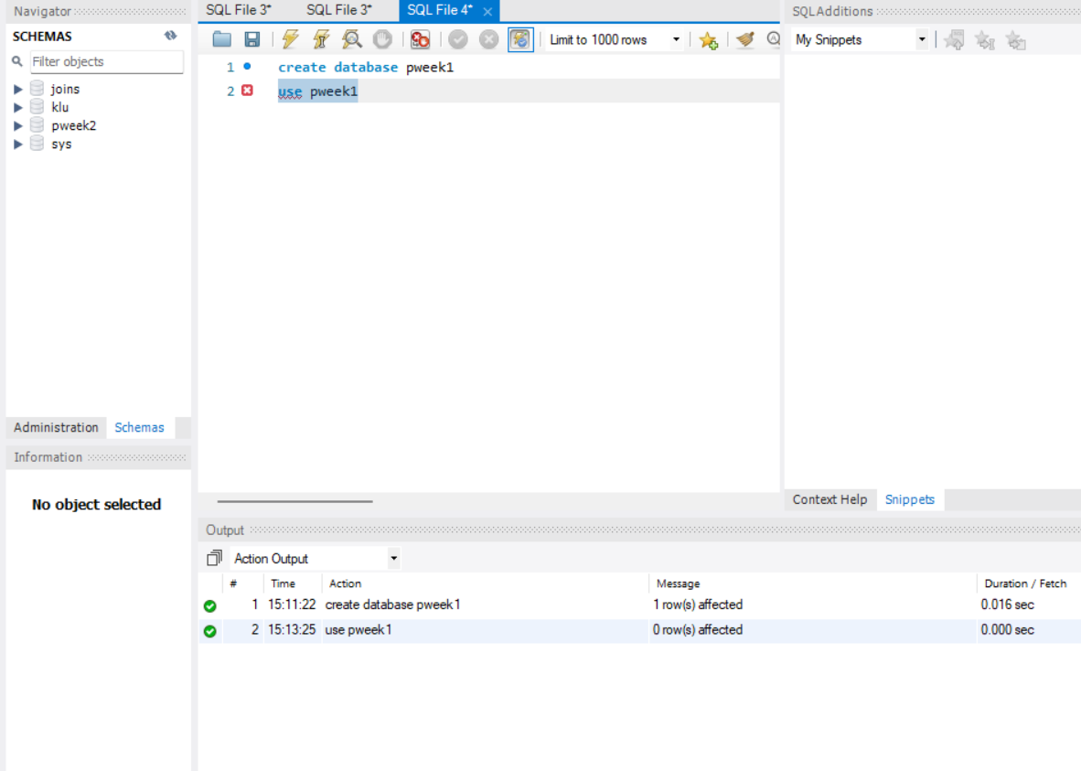
Query 3: Create the books table
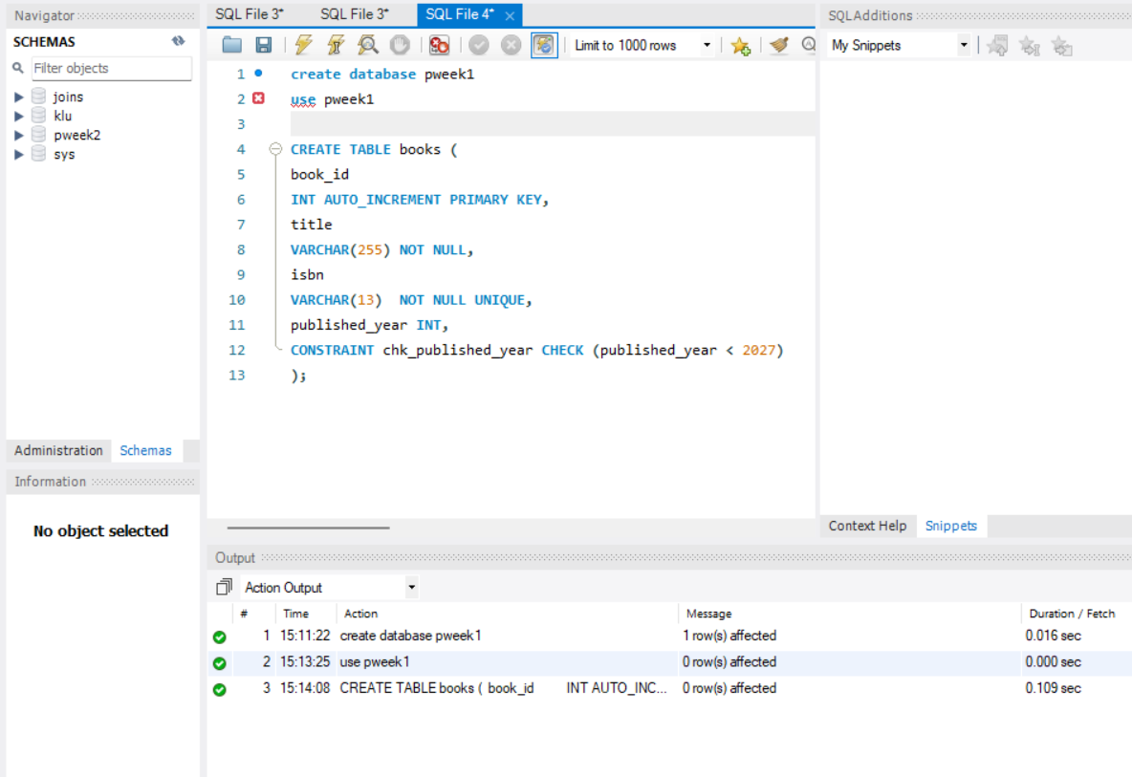
Query 4: Create the members table
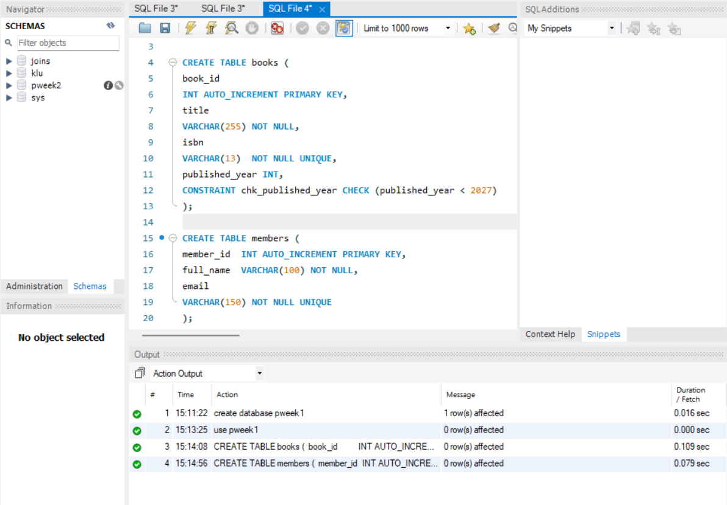

Query 5 (verification): Inspect the table structures
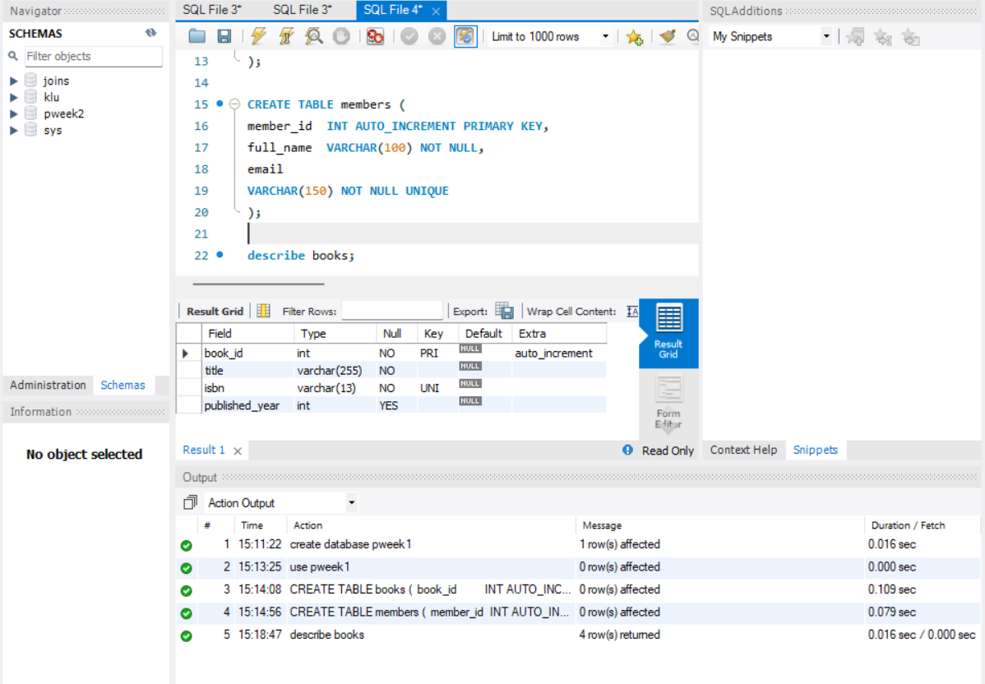
Query 6: Insert 3 books
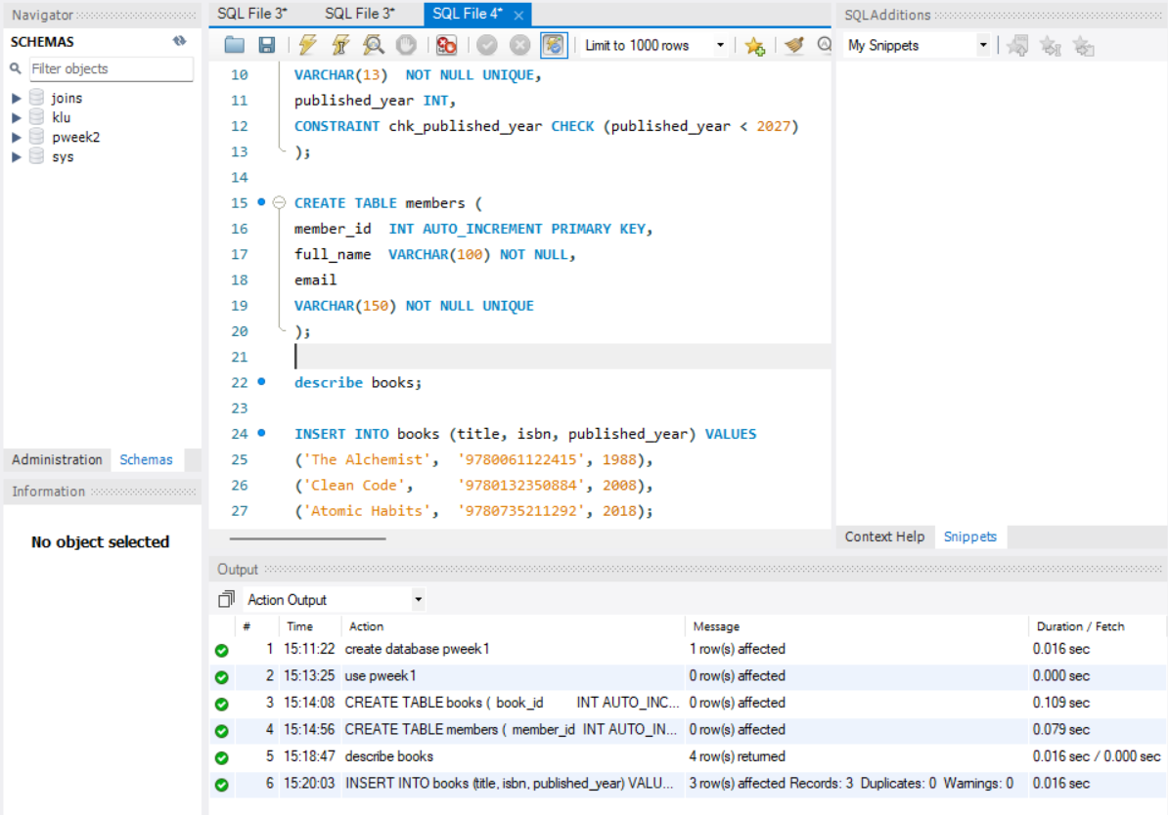

Query 7: Insert 3 members
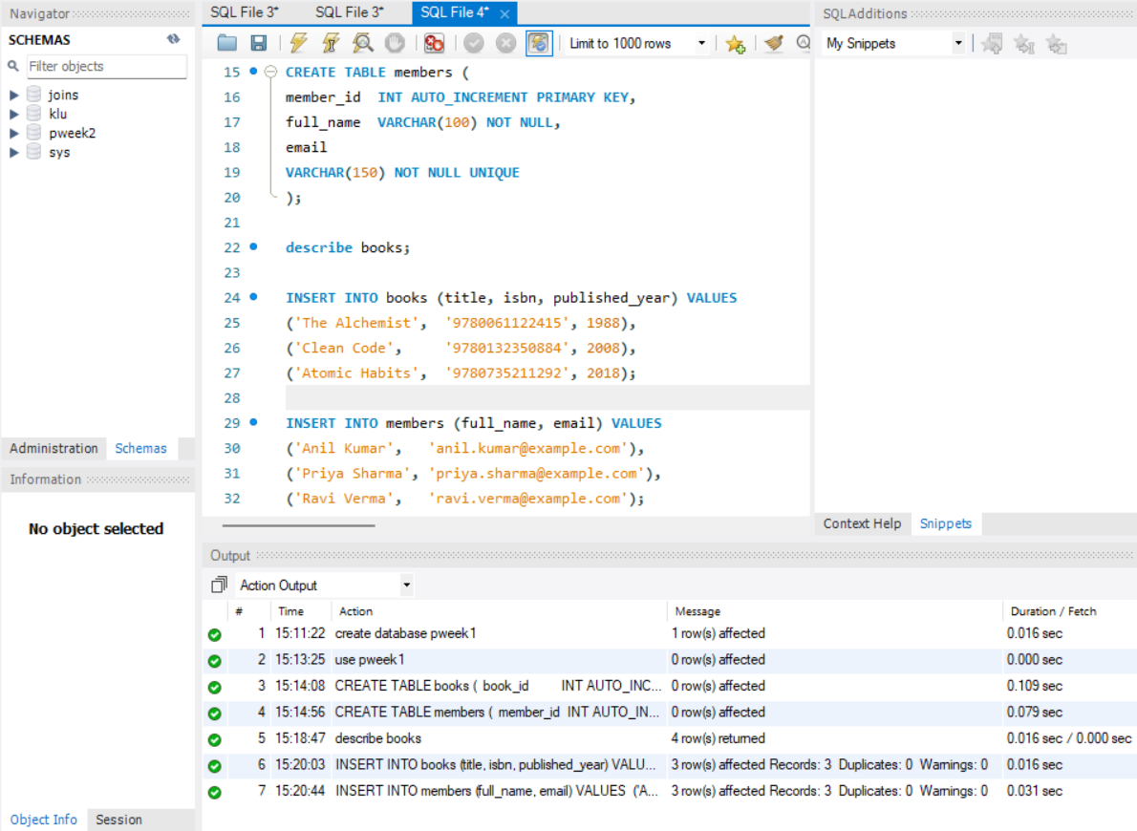

Test 1: Duplicate ISBN (UNIQUE violation)
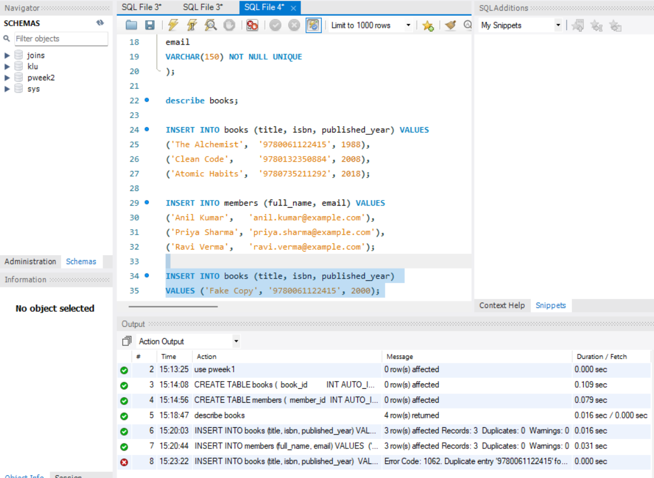
Test 2: NULL title (NOT NULL violation)
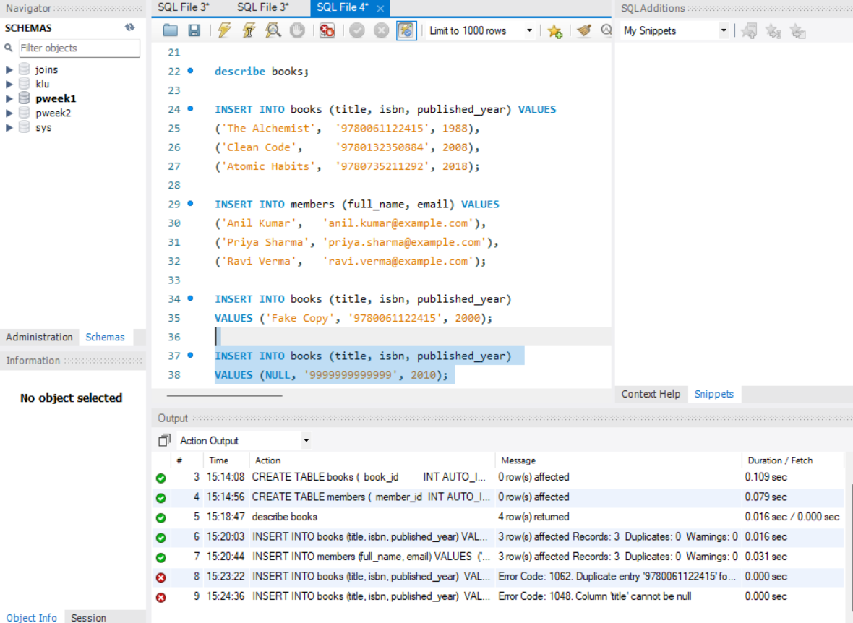
Test 3: Future publication year (CHECK violation)
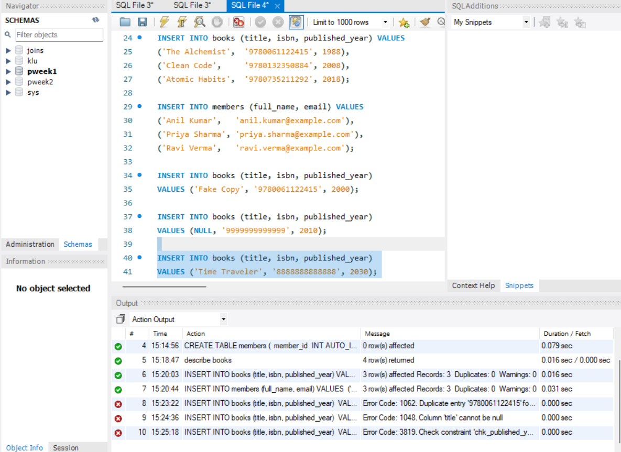
Test 4: Duplicate email (UNIQUE violation)
